HAZMAT RESPONSE INCIDENT REPORT

Use this report for all Non-Accident Releases (NAR’s) and Accident Caused Releases. Conduct a job specific safety briefing, know your protection and know your product.
Return to HazMat Manager that initiated you within 3 days.
*Car Number:
(ex: UTLX 1234)
*Required
EVENT INFORMATION:
Date  Notified: |  |  |  |  | Time Notified:  (Use 24 Hr. Time) |  |  |  |  |  |  |  |  |  | CT  ☐ |  | MT  ☐ | PT  ☐ |  | Arrival  Date: |  |  |  |  |  |  |  | Time of Arrival  (Use 24 Hr. Time) |  |  |  |  |  |  |  |  |  | CT  ☐ |  | MT  ☐ |  | PT  ☐
Address of  Incident: |  |  |  |  |  |  |  |  |  |  |  |  |  |  |  |  |  |  |  |  |  | City: |  |  |  |  |  |  |  |  |  | ST: |  |  |  |  |  | Zip:
County: |  |  |  |  |  |  |  |  |  |  | Train Yard/Hub  Address: |  |  |  |  |  |  |  |  |  |  |  |  |  |  |  |  |  |  |  |  | Track/  Lot No:
Mainline  City: |  |  |  |  |  |  |  | Mainline  County: |  |  |  |  |  |  |  | Milepost/  GPS: |  |  |  |  |  |  |  |  |  |  | Name of person First Contacted on Scene:
*Latitude:  (8 digits) |  |  |  |  |  |  |  |  | *Longitude:  (8 digits) |  |  |  |  |  |  |  |  | Hazardous Class/Division: |  |  |  |  |  |  |  |  |  |  |  |  | UN No.
Proper Shipping Name
of Product:
GENERAL INFORMATION:
Built Date:  Month/Year |  |  |  |  |  |  | Identification Markings:  (ex: DOT111A100W1, 1M 101) |  |  |  |  |  |  |  |  |  |  |  |  |  |  |  |  |  |  |  |  |  |  | PRD Rating: |  |  |  |  |  | PRD  Type:
Last Inspection  Date: |  |  |  |  |  |  |  |  |  | Next Inspection  Date: |  |  |  |  |  |  |  | AAR Cause Code:
 |  |  |  |  |  |  | Seal Numbers: If more seals need to be noted, please indicate in initial findings
Transportation Phase: |  |  |  |  |  |  | Found Location: |  |  |  |  |  |  |  | Found Seal No.: |  |  |  |  |  |  |  |  |  |  | Replaced Location: |  |  |  |  |  |  | Replaced Seal No.:
☐In Transit
☐Loading
☐Unloading
☐In Transit Storage
INITIAL FINDINGS:
 |  |  |  |  |  |  |  |  |  |  |  |  |  |  |  |  |  |  | Estimated Product Lost: |  |  |  |  |  |  |  |  |  |  |  |  |  |  |  |  |  | ☐Gal. ☐ Lbs.

CAR ORIENTATION:
ROOT CAUSE/OTHER OBSERVATIONS:
ACTIONS TAKEN
DISPOSITION OF CAR: (if known) (example: repaired and continuing in transit)
COST ESTIMATE: (This is an estimate only)
Estimated Response Cost: | $ | Estimated Remediation Cost: | $

Show location of Leak(s) and/or damage on diagrams below:
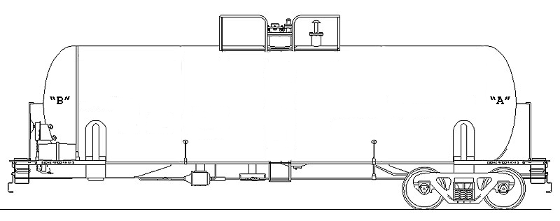 | 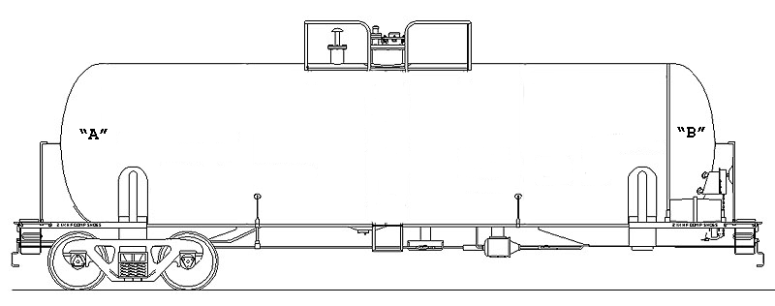
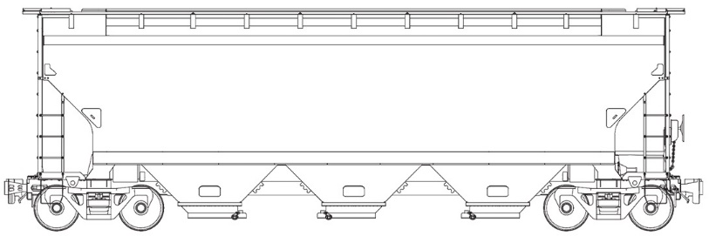
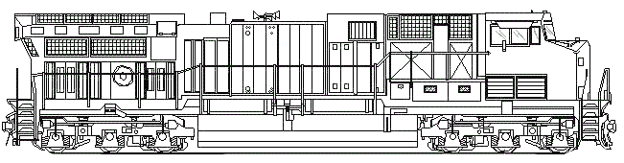 | 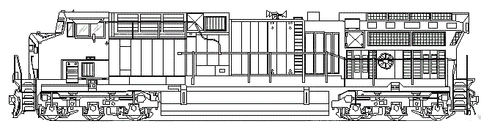
PHOTOS (must be taken of the following items)
☐Equip. ☐ Profile All Sides ☐Qualification Stencil ☐ Build Date ☐ What is Leaking ☐ Seals (Shipper & Replacement) ☐Completed Repairs
Equipment Profile All Sides - Required
Side 1 Side 2

Description/Notes:

Side 3 Side 4
Description/Notes:

QUALIFICATION STENCIL/BUILD DATE - REQUIRED

Qualification Stencil Build Date
Description/Notes:

WHAT IS LEAKING – REQUIRED (Photographs to show exactly what is leaking and where it is leaking from)

Photo 1 Photo 2
Description/Notes:

What is leaking continued.

Photo 3 Photo 4
Description/Notes:

Photo 5 Photo 6
Description/Notes:

SEALS - REQUIRED

Seal Found on Car Replacement Seal
Description/Notes:

Seals continued:

Seal Found on Car Replacement Seal
Description/Notes:

Seal Found on Car Replacement Seal
Description/Notes:

Seal Found on Car Replacement Seal
Description/Notes:

COMPLETED REPAIRS – REQUIRED (Photographs showing what was repaired, PPE in use, equipment on site, etc.)

Photo 1 Photo 2
Description/Notes:

Completed repairs continued:
Photo 3 Photo 4
Description/Notes:

Photo 5 Photo 6
Description/Notes:

Photo 7 Photo 8
Description/Notes:

ADDITIONAL PHOTOS

Photo 1 Photo 2
Description/Notes:

Response  Contractor: |  |  | Name of Individual Responding:
Contact No: |  | Date Complete: |  |  | Time Complete:  (Use 24 Hr. Time) |  | CT  ☐ | MT  ☐ | PT  ☐

